# Encoder-Decoder架构

最初版本transformer由6组完全相同的encoder和6组完全相同decoder组成。

## 位置编码

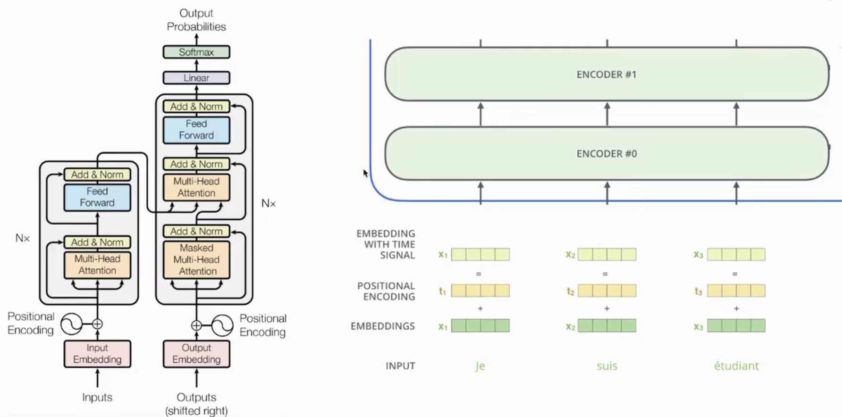

这种方法属于相对位置编码，优点是能够扩展至任意序列长度

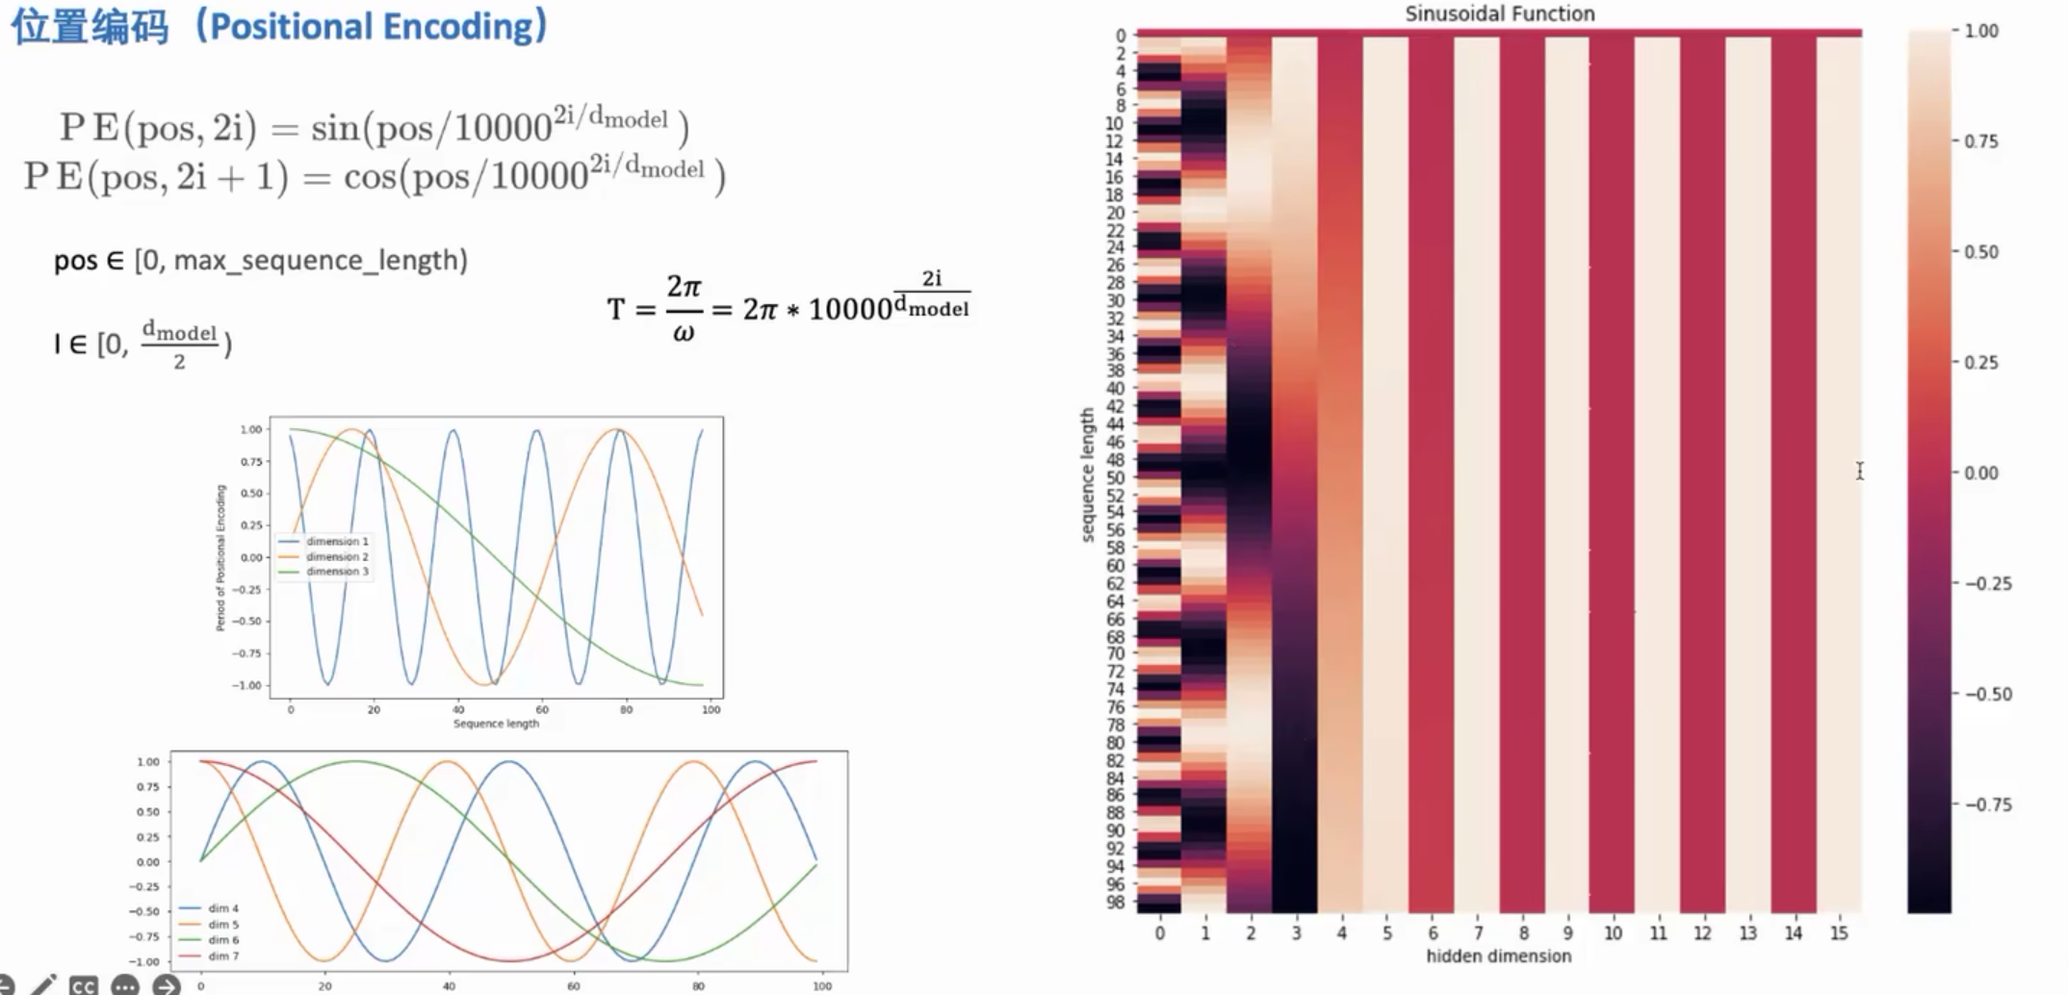

## Self-Attention

1）计算每个单词的Q、K、V

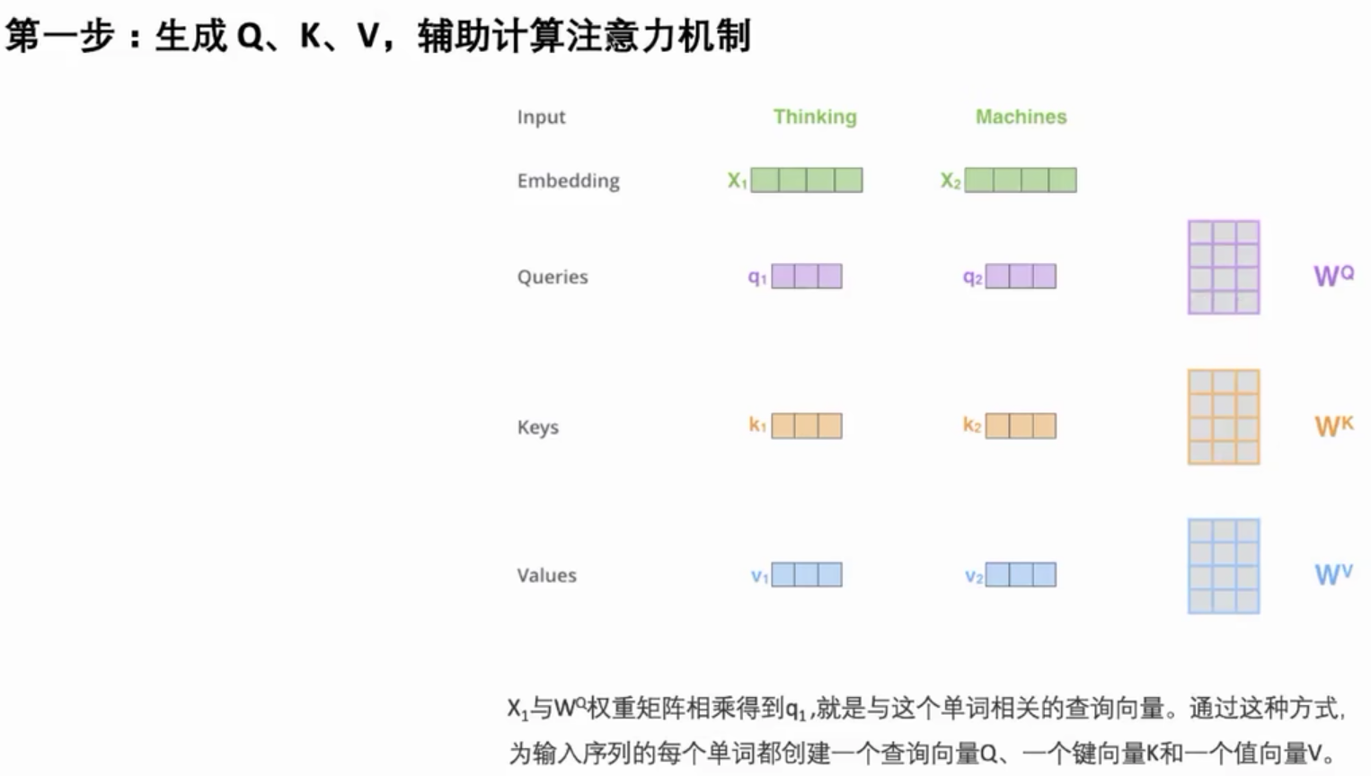

2）按公式计算剩余步骤，这里除以维度（64）的平方根，为了使梯度更稳定

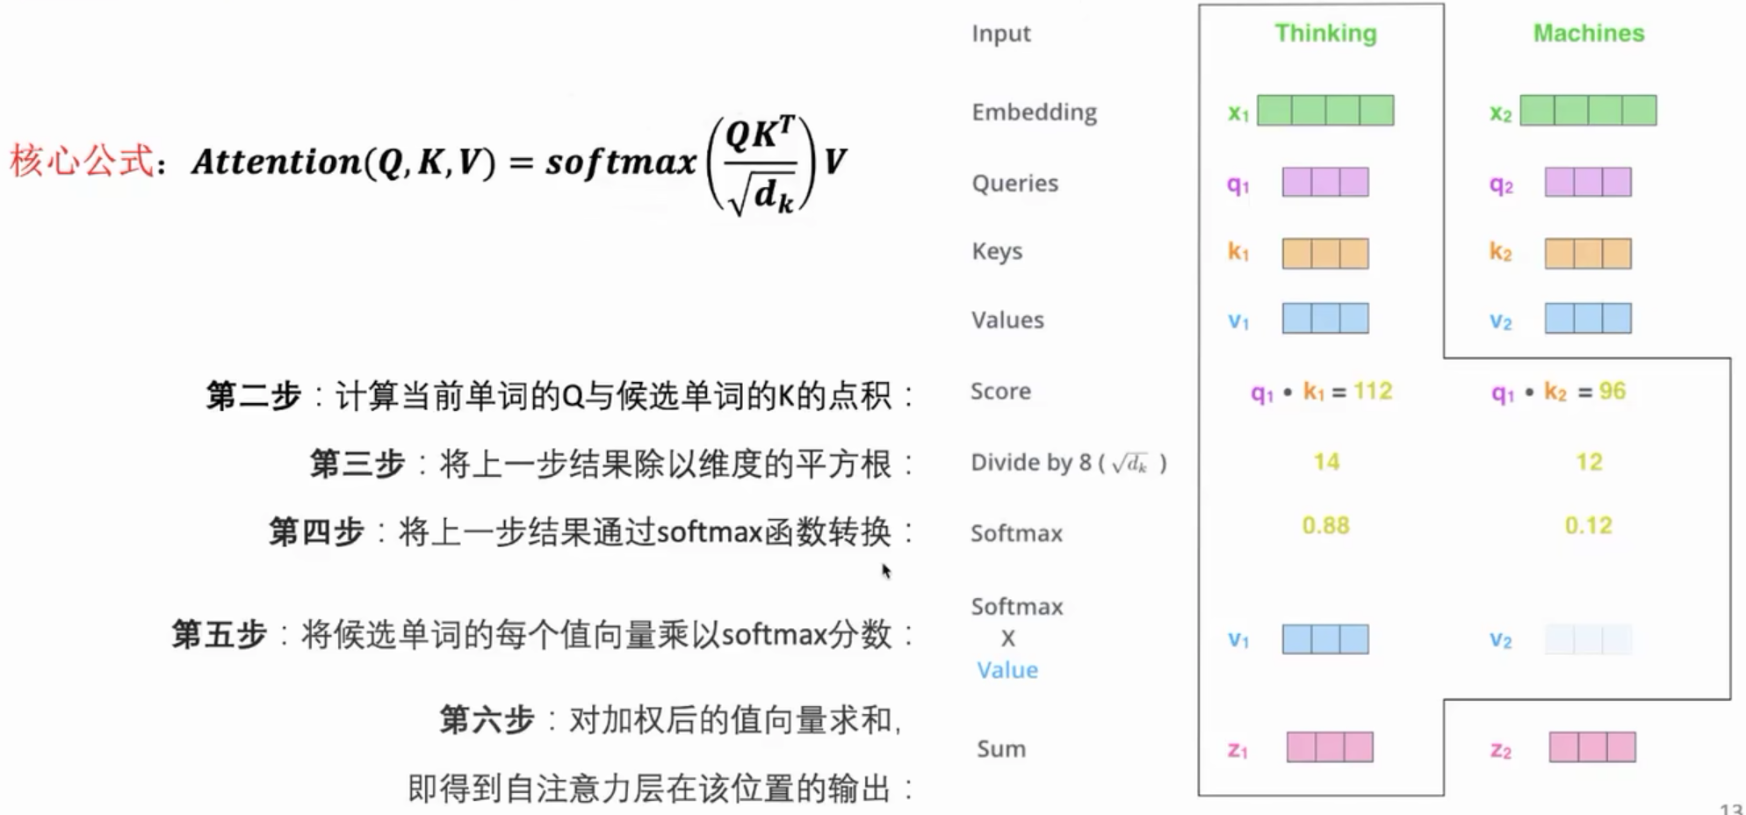

## Muti-Head Attention

为了获取不同层次的信息。

使用8个头，本质上使用了8组不同的转化矩阵WQ、WK、WV，然后合并。

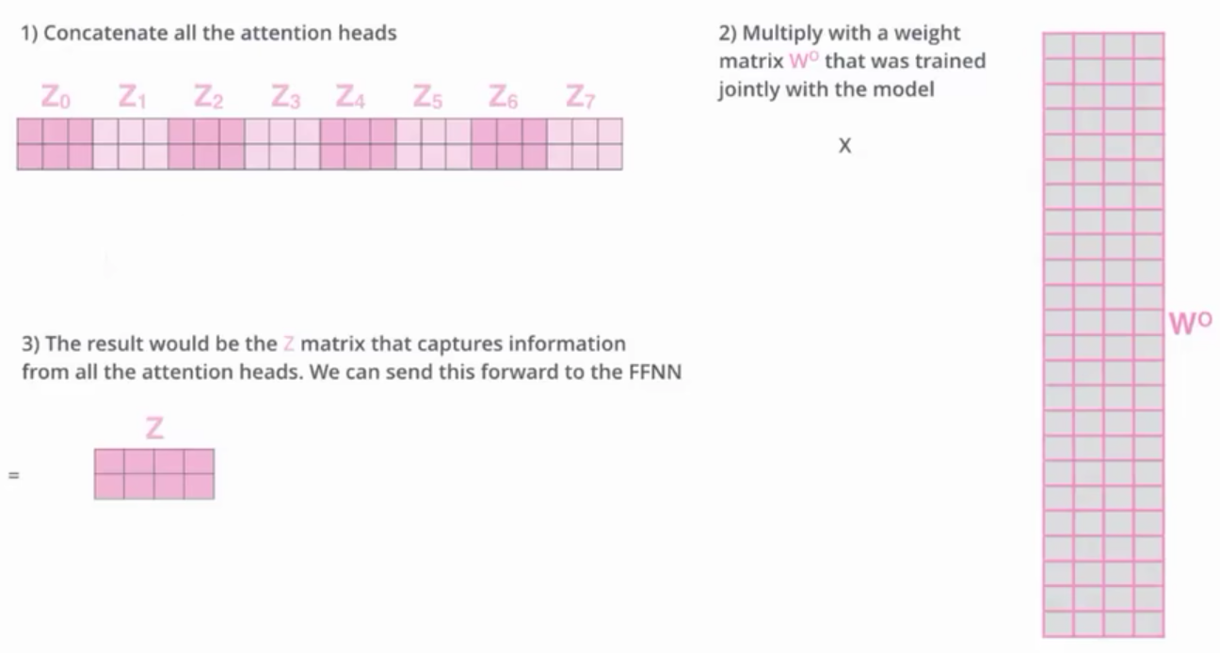

## Padding

为了让batch中序列长度统一。

将短句用-inf补齐，通过数学方式让该位置输出为0，对全局不产生影响

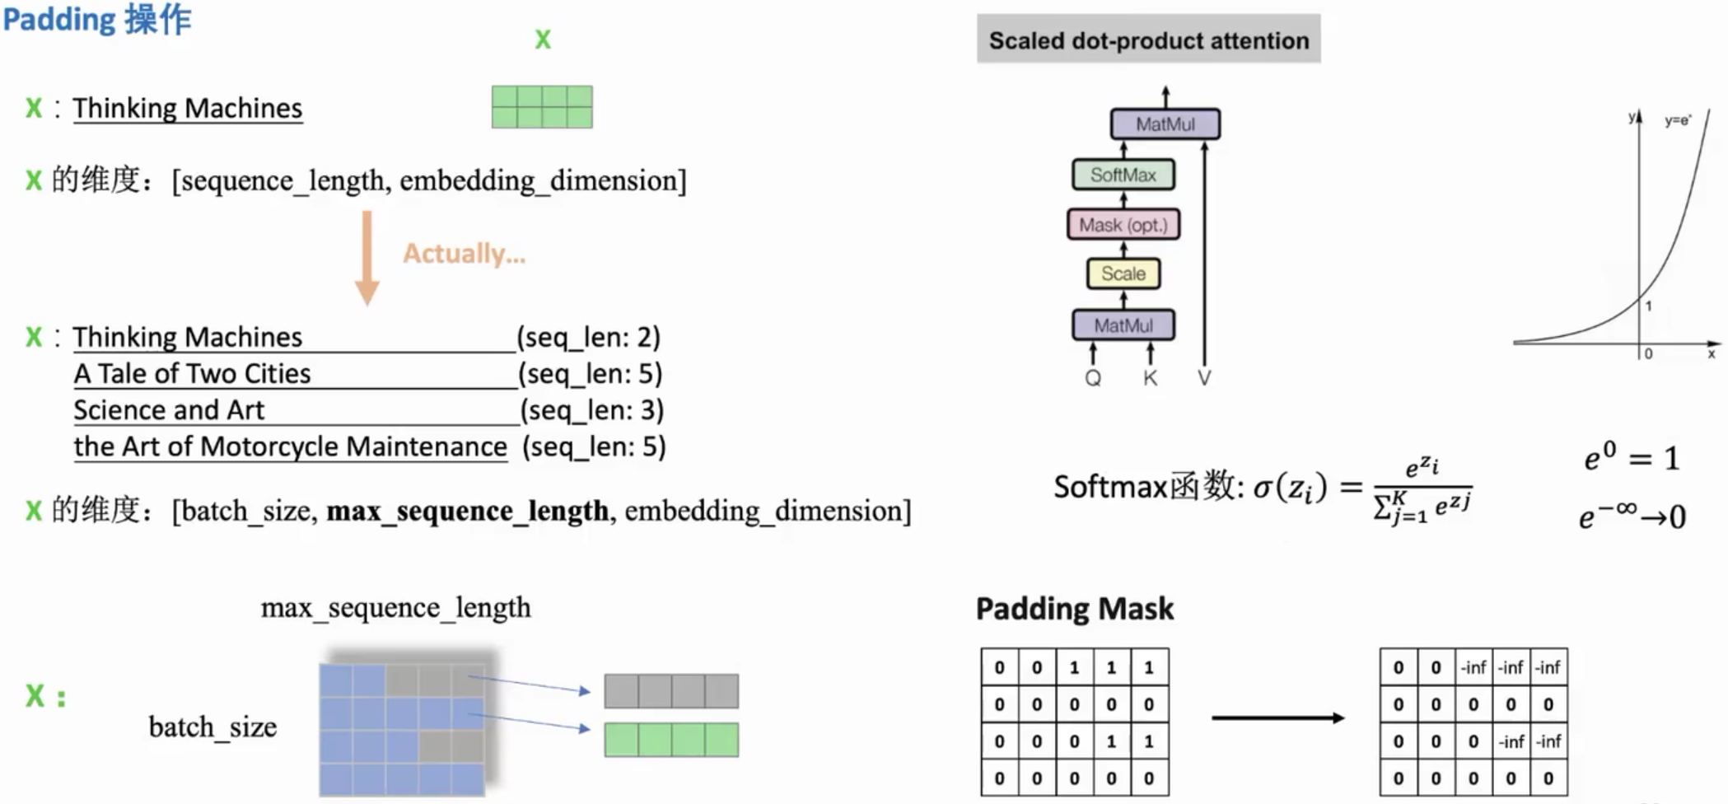

## 残差结构&层归一化

encoder和decoder都用该结构。

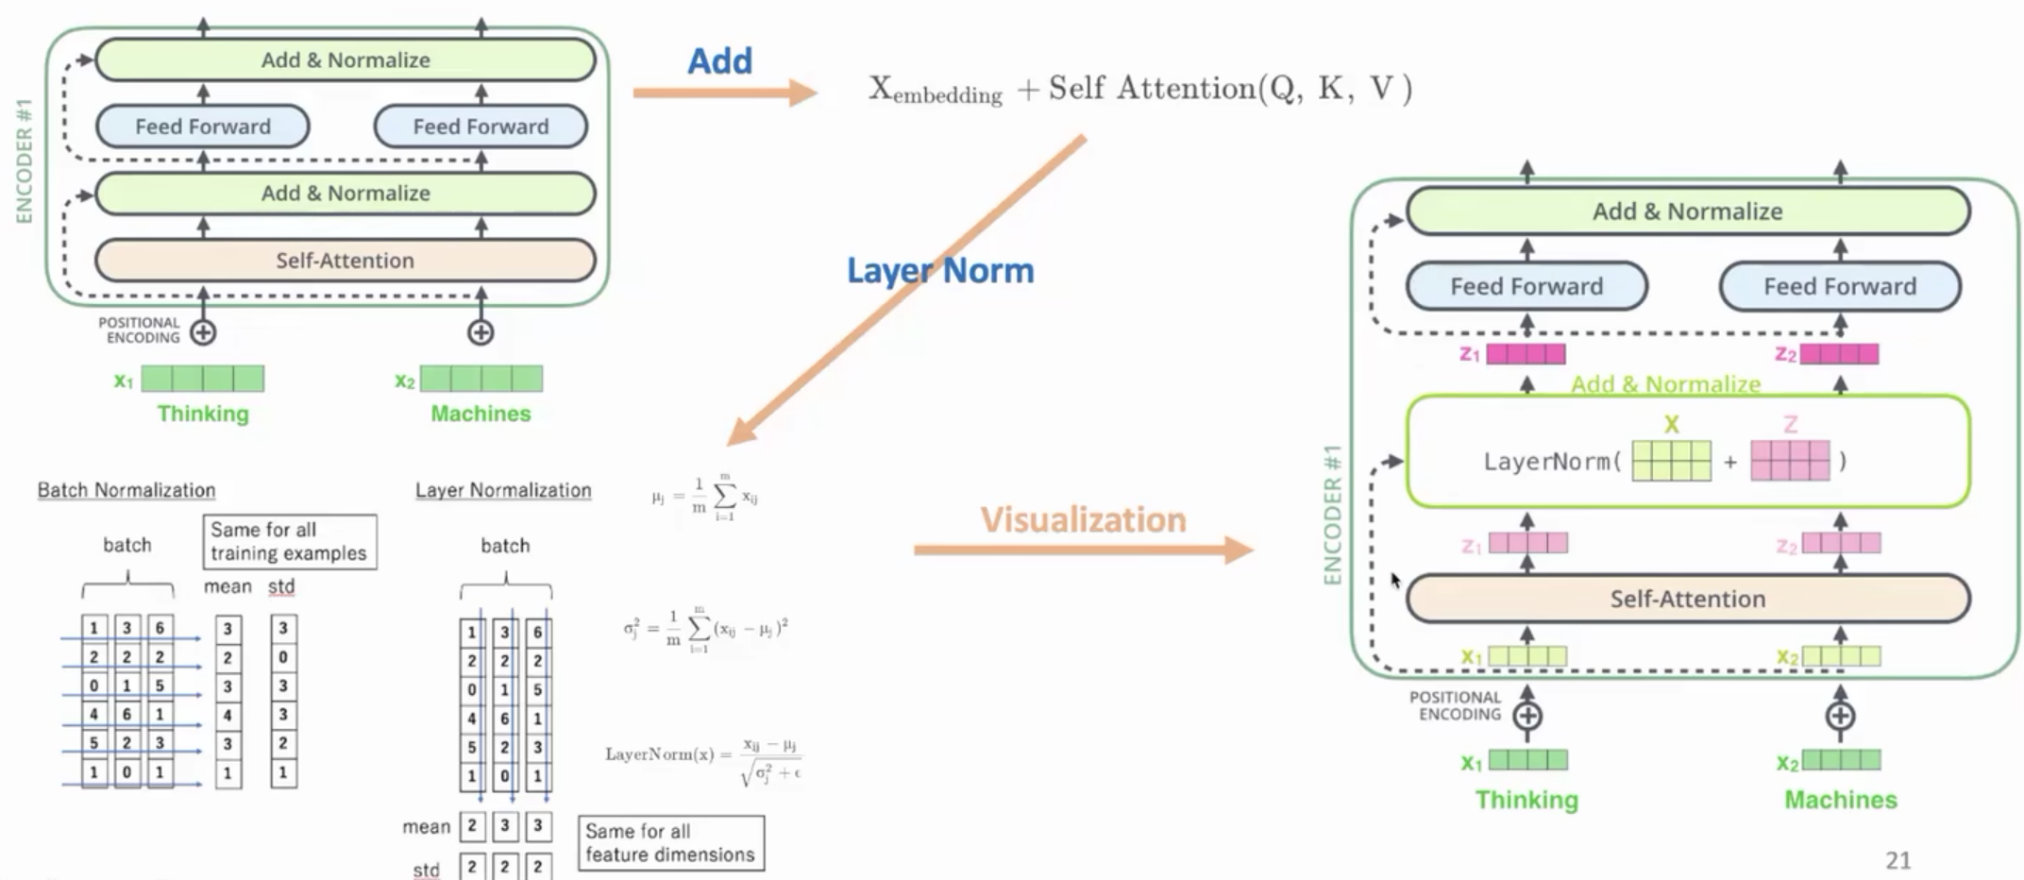

Add+Norm编码流程

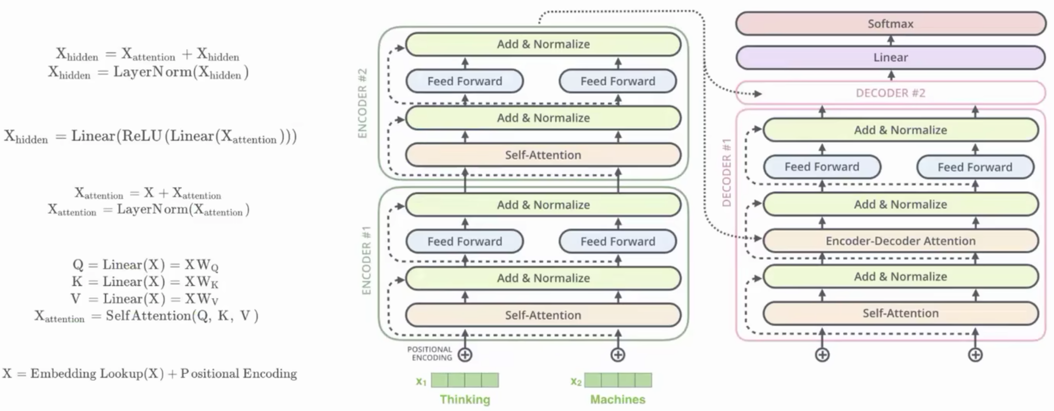

## Masked

Attention内部操作。屏蔽未来信息。

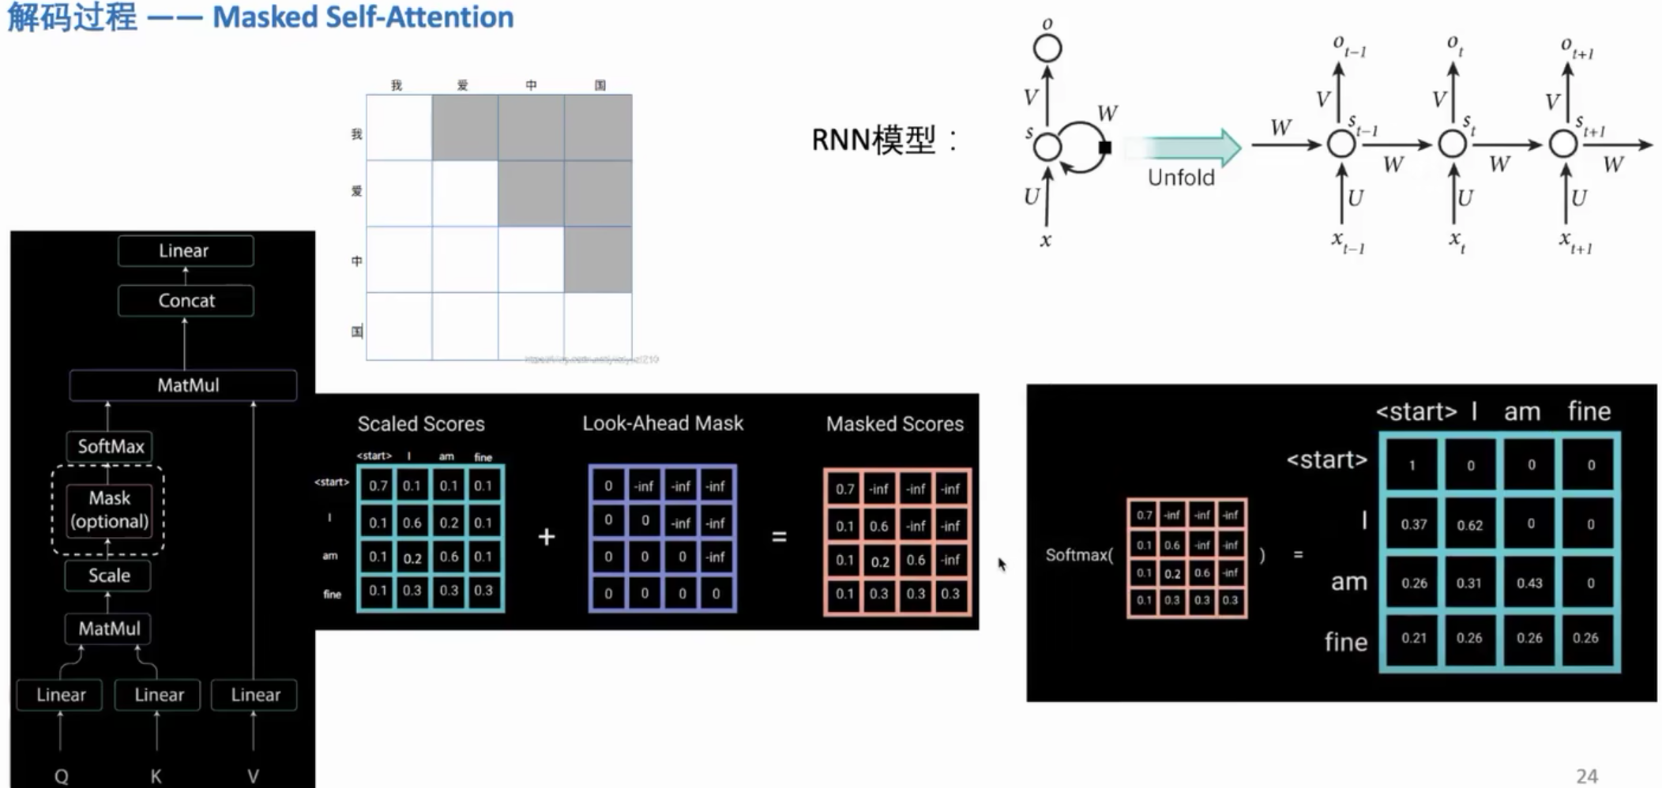

## 解码

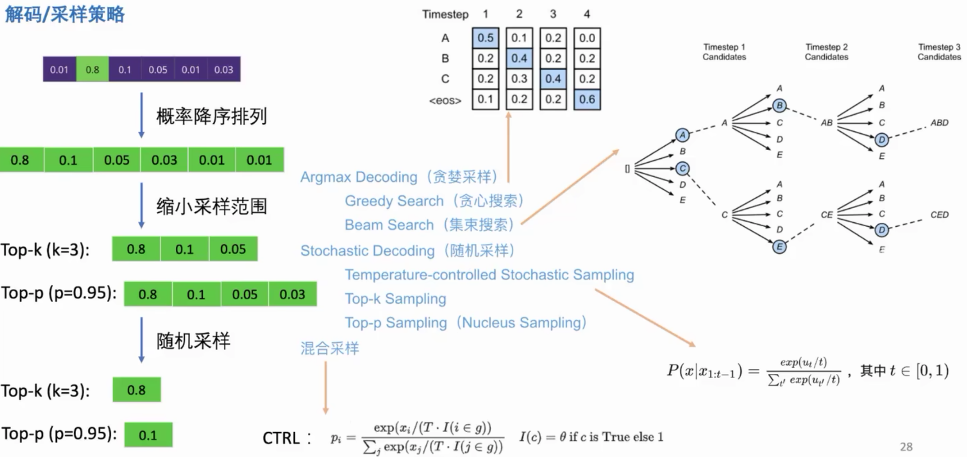

# 训练

Decoder本质Autoregressive，自己做单字接龙。开始时需要给一个begin token，输出结束需要给出end token。输出字典包含{中文字符+end}，使用softmax分类。使用masked屏蔽未来信息，符合输出时“单字接龙”情形。

Cross Attention的k, v来自encoder，而q来自decoder的输入。

扔给Decoder input那部分是正确答案GT。此种训练方式叫Teacher Forcing。

## 数据示例

sentences = [  
 *# enc_input dec_input dec_output* [**'ich mochte ein bier P'**, **'S i want a beer .'**, **'i want a beer . E'**],  
 [**'ich mochte ein cola P'**, **'S i want a coke .'**, **'i want a coke . E'**]  
]  
*# Padding Should be Zero*src_vocab = {**'P'**: 0, **'ich'**: 1, **'mochte'**: 2, **'ein'**: 3, **'bier'**: 4, **'cola'**: 5}  
src_vocab_size = len(src_vocab)  
  
tgt_vocab = {**'P'**: 0, **'i'**: 1, **'want'**: 2, **'a'**: 3, **'beer'**: 4, **'coke'**: 5, **'S'**: 6, **'E'**: 7, **'.'**: 8}  
idx2word = {i: w for i, w in enumerate(tgt_vocab)}  
tgt_vocab_size = len(tgt_vocab)  
src_len = 5 *# enc_input max sequence length*tgt_len = 6 *# dec_input(=dec_output) max sequence length*

def make_data(sentences):  
 enc_inputs, dec_inputs, dec_outputs = [], [], []  
 for i in range(len(sentences)):  
 enc_input = [[src_vocab[n] for n in sentences[i][0].split()]] *# [[1, 2, 3, 4, 0], [1, 2, 3, 5, 0]]* dec_input = [[tgt_vocab[n] for n in sentences[i][1].split()]] *# [[6, 1, 2, 3, 4, 8], [6, 1, 2, 3, 5, 8]]* dec_output = [[tgt_vocab[n] for n in sentences[i][2].split()]] *# [[1, 2, 3, 4, 8, 7], [1, 2, 3, 5, 8, 7]]* enc_inputs.extend(enc_input)  
 dec_inputs.extend(dec_input)  
 dec_outputs.extend(dec_output)  
 return torch.LongTensor(enc_inputs), torch.LongTensor(dec_inputs), torch.LongTensor(dec_outputs)  
enc_inputs, dec_inputs, dec_outputs = make_data(sentences)  
  
class MyDataSet(Data.Dataset):  
 def __init__(self, enc_inputs, dec_inputs, dec_outputs):  
 super(MyDataSet, self).__init__()  
 self.enc_inputs = enc_inputs  
 self.dec_inputs = dec_inputs  
 self.dec_outputs = dec_outputs  
 def __len__(self):  
 return self.enc_inputs.shape[0]  
 def __getitem__(self, idx):  
 return self.enc_inputs[idx], self.dec_inputs[idx], self.dec_outputs[idx]  
  
loader = Data.DataLoader(MyDataSet(enc_inputs, dec_inputs, dec_outputs), 2, True)

## 训练示例

# 模型超参数  
model = Transformer().to(device)  
criterion = nn.CrossEntropyLoss(ignore_index=0)  
optimizer = optim.SGD(model.parameters(), lr=1e-3, momentum=0.99)

for epoch in range(1000):  
 for enc_inputs, dec_inputs, dec_outputs in loader:  
 **'''  
 enc_inputs: [batch_size, src_len]  
 dec_inputs: [batch_size, tgt_len]  
 dec_outputs: [batch_size, tgt_len]  
 '''** enc_inputs, dec_inputs, dec_outputs = enc_inputs.to(device), dec_inputs.to(device), dec_outputs.to(device)  
 *# outputs: [batch_size * tgt_len, tgt_vocab_size]* outputs, enc_self_attns, dec_self_attns, dec_enc_attns = model(enc_inputs, dec_inputs)  
 loss = criterion(outputs, **dec_outputs.view(-1)**)  
 print(**'Epoch:'**, **'%04d'** % (epoch + 1), **'loss ='**, **'{:.6f}'**.format(loss))  
 optimizer.zero_grad()  
 loss.backward()# 每个batch反向计算前先zero_grad将梯度清零  
 optimizer.step()

如果不是每一个batch就清除掉原有的梯度，而是比如说两个batch再清除掉梯度，这是一种变相提高batch_size的方法，对于计算机硬件不行，但是batch_size可能需要设高的领域比较适合，比如目标检测模型的训练。

# 编码实现

*# Transformer Parameters*d_model = 512 *# Embedding Size*d_ff = 2048 *# FeedForward dimension*d_k = d_v = 64 *# dimension of K(=Q), V*n_layers = 6 *# number of Encoder of Decoder Layer*n_heads = 8 *# number of heads in Multi-Head Attention*

## 位置编码

class PositionalEncoding(nn.Module):  
 def __init__(self, d_model, dropout=0.1, max_len=5000):  
 super(PositionalEncoding, self).__init__()  
 self.dropout = nn.Dropout(p=dropout)  
 pe = torch.zeros(max_len, d_model)  
 position = torch.arange(0, max_len, dtype=torch.float).unsqueeze(1)  
 div_term = torch.exp(torch.arange(0, d_model, 2).float() * (-math.log(10000.0) / d_model))  
 pe[:, 0::2] = torch.sin(position * div_term)  
 pe[:, 1::2] = torch.cos(position * div_term)  
 pe = pe.unsqueeze(0).transpose(0, 1)  
 self.register_buffer(**'pe'**, pe)  
 def forward(self, x):  
 *'''  
 x: [seq_len, batch_size, d_model]  
 '''* x = x + self.pe[:x.size(0), :]  
 return self.dropout(x)

## Encoder

class Encoder(nn.Module):  
 def __init__(self):  
 super(Encoder, self).__init__()  
 self.src_emb = nn.Embedding(src_vocab_size, d_model)  
 self.pos_emb = PositionalEncoding(d_model)  
 self.layers = nn.ModuleList([EncoderLayer() for _ in range(n_layers)])  
 def forward(self, enc_inputs):  
 *'''  
 enc_inputs: [batch_size, src_len]  
 '''* enc_outputs = self.src_emb(enc_inputs) *# [batch_size, src_len, d_model]* enc_outputs = self.pos_emb(enc_outputs.transpose(0, 1)).transpose(0, 1) *# [batch_size, src_len, d_model]* enc_self_attn_mask = get_attn_pad_mask(enc_inputs, enc_inputs) *# [batch_size, src_len, src_len]* enc_self_attns = []  
 for layer in self.layers:  
 *# enc_outputs: [batch_size, src_len, d_model], enc_self_attn: [batch_size, n_heads, src_len, src_len]* enc_outputs, enc_self_attn = layer(enc_outputs, enc_self_attn_mask)  
 enc_self_attns.append(enc_self_attn)  
 return enc_outputs, enc_self_attns

class EncoderLayer(nn.Module):  
 def __init__(self):  
 super(EncoderLayer, self).__init__()  
 self.enc_self_attn = MultiHeadAttention()  
 self.pos_ffn = PoswiseFeedForwardNet()  
 def forward(self, enc_inputs, enc_self_attn_mask):  
 *'''  
 enc_inputs: [batch_size, src_len, d_model]  
 enc_self_attn_mask: [batch_size, src_len, src_len]  
 '''  
 # enc_outputs: [batch_size, src_len, d_model], attn: [batch_size, n_heads, src_len, src_len]* enc_outputs, attn = self.enc_self_attn(enc_inputs, enc_inputs, enc_inputs,  
 enc_self_attn_mask) *# enc_inputs to same Q,K,V* enc_outputs = self.pos_ffn(enc_outputs) *# enc_outputs: [batch_size, src_len, d_model]* return enc_outputs, attn

### MultiHeadAttention

class MultiHeadAttention(nn.Module):  
 def __init__(self):  
 super(MultiHeadAttention, self).__init__()  
 self.W_Q = nn.Linear(d_model, d_k * n_heads, bias=False)  
 self.W_K = nn.Linear(d_model, d_k * n_heads, bias=False)  
 self.W_V = nn.Linear(d_model, d_v * n_heads, bias=False)  
 self.fc = nn.Linear(n_heads * d_v, d_model, bias=False)  
  
 def forward(self, input_Q, input_K, input_V, attn_mask):  
 *'''  
 input_Q: [batch_size, len_q, d_model]  
 input_K: [batch_size, len_k, d_model]  
 input_V: [batch_size, len_v(=len_k), d_model]  
 attn_mask: [batch_size, seq_len, seq_len]  
 '''* residual, batch_size = input_Q, input_Q.size(0)  
 *# (B, S, D) -proj-> (B, S, D_new) -split-> (B, S, H, W) -trans-> (B, H, S, W)* **Q = self.W_Q(input_Q).view(batch_size, -1, n_heads, d_k).transpose(1, 2)** *# Q: [batch_size, n_heads, len_q, d_k]* K = self.W_K(input_K).view(batch_size, -1, n_heads, d_k).transpose(1, 2) *# K: [batch_size, n_heads, len_k, d_k]* V = self.W_V(input_V).view(batch_size, -1, n_heads, d_v).transpose(1, 2) *# V: [batch_size, n_heads, len_v(=len_k), d_v]* attn_mask = attn_mask.unsqueeze(1).repeat(1, n_heads, 1, 1) *# attn_mask : [batch_size, n_heads, seq_len, seq_len]  
 # context: [batch_size, n_heads, len_q, d_v], attn: [batch_size, n_heads, len_q, len_k]* context, attn = ScaledDotProductAttention()(Q, K, V, attn_mask)  
 **context = context.transpose(1, 2).reshape(batch_size, -1, n_heads * d_v)** *# context: [batch_size, len_q, n_heads * d_v]* **output = self.fc(context)** *# [batch_size, len_q, d_model]* return nn.LayerNorm(d_model).to(device)(output + residual), attn

class **ScaledDotProductAttention**(nn.Module):  
 def __init__(self):  
 super(ScaledDotProductAttention, self).__init__()  
 def forward(self, Q, K, V, attn_mask):  
 *'''  
 Q: [batch_size, n_heads, len_q, d_k]  
 K: [batch_size, n_heads, len_k, d_k]  
 V: [batch_size, n_heads, len_v(=len_k), d_v]  
 attn_mask: [batch_size, n_heads, seq_len, seq_len]  
 '''* **scores = torch.matmul(Q, K.transpose(-1, -2)) / np.sqrt(d_k)** *# scores : [batch_size, n_heads, len_q, len_k]* **scores.masked_fill_(attn_mask, -1e9)** *# Fills elements of self tensor with value where mask is True.* attn = nn.Softmax(dim=-1)(scores)  
 context = torch.matmul(attn, V) *# [batch_size, n_heads, len_q, d_v]* return context, attn

### PoswiseFeedForwardNet

class PoswiseFeedForwardNet(nn.Module):  
 def __init__(self):  
 super(PoswiseFeedForwardNet, self).__init__()  
 self.fc = nn.Sequential(  
 nn.Linear(d_model, d_ff, bias=False),  
 nn.ReLU(),  
 nn.Linear(d_ff, d_model, bias=False)  
 )  
 def forward(self, inputs):  
 *'''  
 inputs: [batch_size, seq_len, d_model]  
 '''* residual = inputs  
 output = self.fc(inputs)  
 return **nn.LayerNorm(d_model).to(device)(output + residual)** *# [batch_size, seq_len, d_model]*

## Decoder

class Decoder(nn.Module):  
 def __init__(self):  
 super(Decoder, self).__init__()  
 self.tgt_emb = nn.Embedding(tgt_vocab_size, d_model)  
 self.pos_emb = PositionalEncoding(d_model)  
 self.layers = nn.ModuleList([DecoderLayer() for _ in range(n_layers)])  
 def forward(self, dec_inputs, enc_inputs, enc_outputs):  
 *'''  
 dec_inputs: [batch_size, tgt_len]  
 enc_intpus: [batch_size, src_len]  
 enc_outputs: [batsh_size, src_len, d_model]  
 '''* dec_outputs = self.tgt_emb(dec_inputs) *# [batch_size, tgt_len, d_model]* dec_outputs = self.pos_emb(dec_outputs.transpose(0, 1)).transpose(0, 1).to(device) *# [batch_size, tgt_len, d_model]* dec_self_attn_pad_mask = get_attn_pad_mask(dec_inputs, dec_inputs).to(device) *# [batch_size, tgt_len, tgt_len]* dec_self_attn_subsequence_mask = get_attn_subsequence_mask(dec_inputs).to(device) *# [batch_size, tgt_len, tgt_len]* dec_self_attn_mask = torch.gt((dec_self_attn_pad_mask + dec_self_attn_subsequence_mask), 0).to(device) *# [batch_size, tgt_len, tgt_len]* dec_enc_attn_mask = get_attn_pad_mask(dec_inputs, enc_inputs) *# [batc_size, tgt_len, src_len]* dec_self_attns, dec_enc_attns = [], []  
 for layer in self.layers:  
 *# dec_outputs: [batch_size, tgt_len, d_model], dec_self_attn: [batch_size, n_heads, tgt_len, tgt_len], dec_enc_attn: [batch_size, h_heads, tgt_len, src_len]* dec_outputs, dec_self_attn, dec_enc_attn = layer(dec_outputs, enc_outputs, dec_self_attn_mask, dec_enc_attn_mask)  
 dec_self_attns.append(dec_self_attn)  
 dec_enc_attns.append(dec_enc_attn)  
 return dec_outputs, dec_self_attns, dec_enc_attns

class DecoderLayer(nn.Module):  
 def __init__(self):  
 super(DecoderLayer, self).__init__()  
 self.dec_self_attn = MultiHeadAttention()  
 self.dec_enc_attn = MultiHeadAttention()  
 self.pos_ffn = PoswiseFeedForwardNet()  
 def forward(self, dec_inputs, enc_outputs, dec_self_attn_mask, dec_enc_attn_mask):  
 *'''  
 dec_inputs: [batch_size, tgt_len, d_model]  
 enc_outputs: [batch_size, src_len, d_model]  
 dec_self_attn_mask: [batch_size, tgt_len, tgt_len]  
 dec_enc_attn_mask: [batch_size, tgt_len, src_len]  
 '''  
 # dec_outputs: [batch_size, tgt_len, d_model], dec_self_attn: [batch_size, n_heads, tgt_len, tgt_len]* dec_outputs, dec_self_attn = self.dec_self_attn(dec_inputs, dec_inputs, dec_inputs, dec_self_attn_mask)  
 *# dec_outputs: [batch_size, tgt_len, d_model], dec_enc_attn: [batch_size, h_heads, tgt_len, src_len]* dec_outputs, dec_enc_attn = self.dec_enc_attn(dec_outputs, enc_outputs, enc_outputs, dec_enc_attn_mask)  
 dec_outputs = self.pos_ffn(dec_outputs) *# [batch_size, tgt_len, d_model]* return dec_outputs, dec_self_attn, dec_enc_attn

## Padding

def get_attn_pad_mask(seq_q, seq_k):  
 *'''  
 seq_q: [batch_size, seq_len]  
 seq_k: [batch_size, seq_len]  
 seq_len could be src_len or it could be tgt_len  
 seq_len in seq_q and seq_len in seq_k maybe not equal  
 '''* batch_size, len_q = seq_q.size()  
 batch_size, len_k = seq_k.size()  
 *# eq(zero) is PAD token* pad_attn_mask = seq_k.data.eq(0).unsqueeze(1) *# [batch_size, 1, len_k], False is masked* return pad_attn_mask.expand(batch_size, len_q, len_k) *# [batch_size, len_q, len_k]*

def get_attn_subsequence_mask(seq):  
 *'''  
 seq: [batch_size, tgt_len]  
 '''* attn_shape = [seq.size(0), seq.size(1), seq.size(1)]  
 subsequence_mask = np.triu(np.ones(attn_shape), k=1) *# Upper triangular matrix* subsequence_mask = torch.from_numpy(subsequence_mask).byte()  
 return subsequence_mask *# [batch_size, tgt_len, tgt_len]*

## Transfomer

class Transformer(nn.Module):  
 def __init__(self):  
 super(Transformer, self).__init__()  
 self.encoder = Encoder().to(device)  
 self.decoder = Decoder().to(device)  
 self.projection = nn.Linear(d_model, tgt_vocab_size, bias=False).to(device)  
 def forward(self, enc_inputs, dec_inputs):  
 *'''  
 enc_inputs: [batch_size, src_len]  
 dec_inputs: [batch_size, tgt_len]  
 '''  
 # tensor to store decoder outputs  
 # outputs = torch.zeros(batch_size, tgt_len, tgt_vocab_size).to(self.device)  
  
 # enc_outputs: [batch_size, src_len, d_model], enc_self_attns: [n_layers, batch_size, n_heads, src_len, src_len]* enc_outputs, enc_self_attns = self.encoder(enc_inputs)  
 *# dec_outpus: [batch_size, tgt_len, d_model], dec_self_attns: [n_layers, batch_size, n_heads, tgt_len, tgt_len], dec_enc_attn: [n_layers, batch_size, tgt_len, src_len]* dec_outputs, dec_self_attns, dec_enc_attns = self.decoder(dec_inputs, enc_inputs, enc_outputs)  
 dec_logits = self.projection(dec_outputs) *# dec_logits: [batch_size, tgt_len, tgt_vocab_size]* return dec_logits.view(-1, dec_logits.size(-1)), enc_self_attns, dec_self_attns, dec_enc_attns

## 解码

def greedy_decoder(model, enc_input, start_symbol):  
 *"""  
 For simplicity, a Greedy Decoder is Beam search when K=1. This is necessary for inference as we don't know the target sequence input. Therefore we try to generate the target input word by word, then feed it into the transformer.  
 """* enc_outputs, enc_self_attns = model.encoder(enc_input)  
 dec_input = torch.zeros(1, 0).type_as(enc_input.data)  
 terminal = False  
 next_symbol = start_symbol  
 while not terminal:  
 dec_input = torch.cat([dec_input.detach(), torch.tensor([[next_symbol]], dtype=enc_input.dtype).to(device)], -1)# detach不参与梯度计算，cat拼接上一轮得到的字符  
 dec_outputs, _, _ = model.decoder(dec_input, enc_input, enc_outputs)  
 projected = model.projection(dec_outputs)  
 prob = projected.squeeze(0).max(dim=-1, keepdim=False)[1]# squeeze压缩维度，[1]指ind  
 next_word = prob.data[-1]  
 next_symbol = next_word  
 if next_symbol == tgt_vocab[**"."**]:  
 terminal = True  
 print(next_word)  
 return dec_input

enc_inputs, _, _ = next(iter(loader))  
enc_inputs = enc_inputs.to(device)  
for i in range(len(enc_inputs)):  
 greedy_dec_input = greedy_decoder(model, enc_inputs[i].view(1, -1), start_symbol=tgt_vocab[**"S"**])  
 predict, _, _, _ = model(enc_inputs[i].view(1, -1), greedy_dec_input)  
 predict = predict.data.max(1, keepdim=True)[1]  
 print(enc_inputs[i], **'->'**, [idx2word[n.item()] for n in predict.squeeze()])